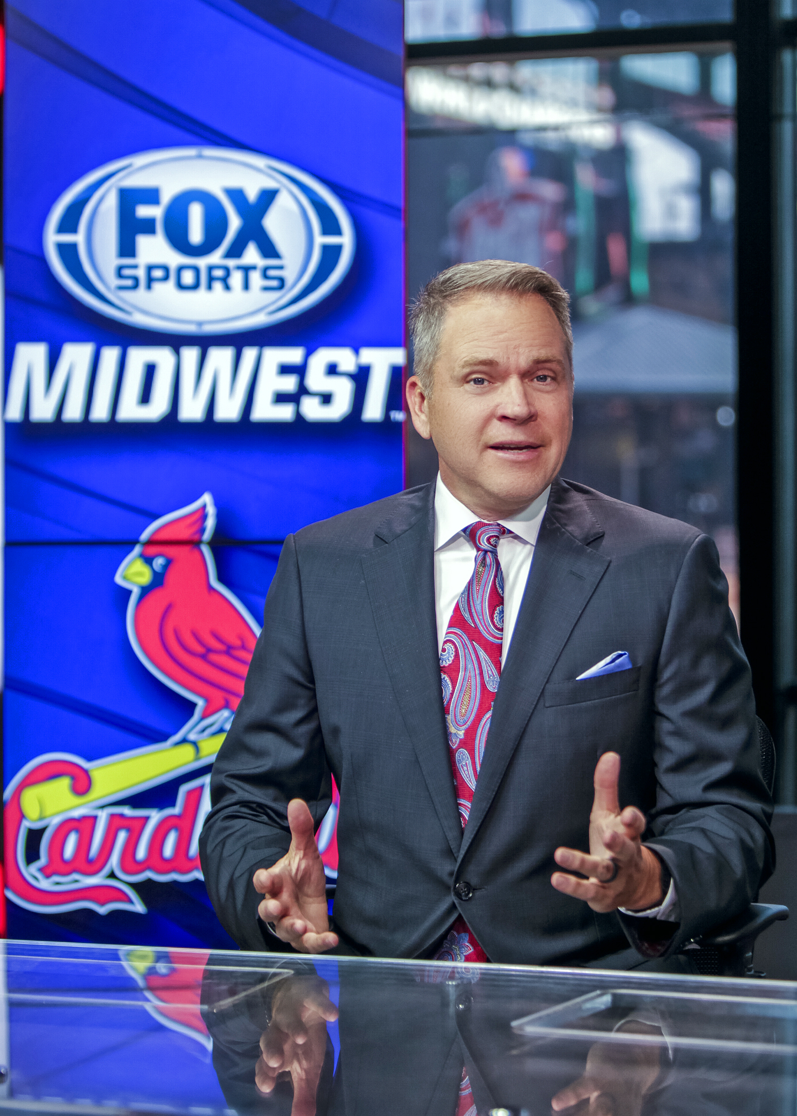  - FEBRUARY 3 -  WESTERN IL FCA BANQUET  RICKY HORTON  Former St. Louis Cardinal Pitcher and Fox Sports Midwest Broadcaster Ricky Horton will be the keynote speaker for the Western IL FCA Banquet on FEBRUARY 3rd at 1:15pm in the WIU Heritage Room. The banquet is free, but an offering will be received. Reservations required at www.WesternILFCA.org.  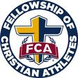 Western IL FCA Home Team Banquet | Make Reservations Now / No Cost to Attend  ____  Serve as a Table Host and Bring Your Friends  ____  February 3rd @ 1:15pm  ____  Become a Banquet Sponsor  ____  Reservations Required @ www.westernilfca.org  Fellowship of Christian Athletes  For more information:  tsweatman@fca.org  217-370-2008  www.WesternILFca.org  FEBRUARY 3 @ 1:15

